**Cisco Network Testbed Architecture**

**Question framing for Kaggle.com**

**Team Members:** Dhairya Modi, Yinzhong Tang, Prabhakar Nanduri **Team Number:** 3(three)

Plotting the portflap dataset onto tableau and correlating it with the log and readme files, we can see the portflap failure clearly as shown below. The four drops in the input/output packet rate checks with the epoch time of the onset of the failure (given in the log files). The eventual rise of the packet rates also shows network stabilization.

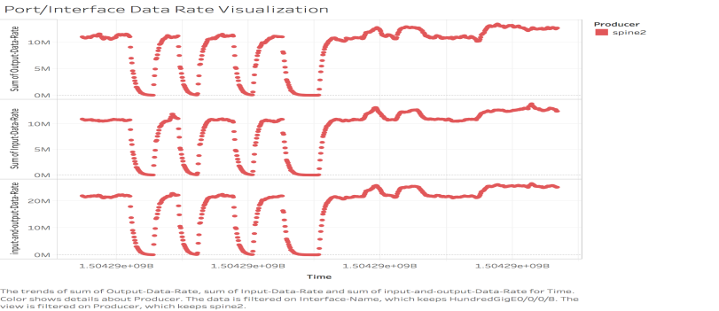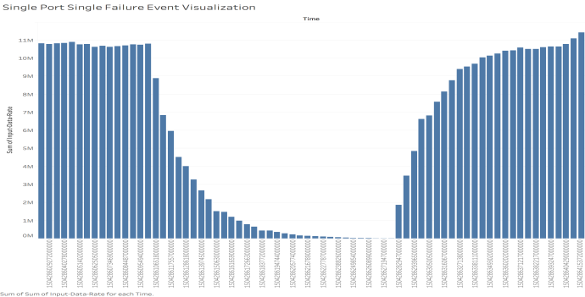

**Draft Question:**

To predict the port/interface failure of a particular network element within the first few initial seconds of network disturbance. Once prediction for port/interface failure is made the next ask will be to categorize the failure into the below mentioned six categories:-

(a) Transceiver pull local end (b) transceiver pull remote end (c) admin down local end (d) admin down remote end (e) fiber pull local end (f) fiber pull remote end

**Metrics for Evaluation:**

1. Average information gain of the model developed; the information gain calculation to incorporate the correct classification of the type of portflap fault. [Similar to the metric used last semester]
2. F1 score/F score. This score is a harmonic average of the precision and recall, [see: <https://en.wikipedia.org/wiki/F1_score> ]. This scoring metric can be used in conjunction with the average information gain metric as a tool to penalise false positives and false negatives.

**Data-sets required:**

Since the competition we are proposing involves building a supervised multi-category classification model, the training sets will have to contain all the six categories of faults for either just one network element or various network elements. Our recommendation will be to provide 12 training data sets. 6 of which will be for one leaf and each having one category of port-flap failure. The other 6 will be for one spine with each data-set having one category of port-flap failure. The length of each dataset in time intervals should be for more than 6 minutes since each fault takes about 4 minutes duration from onset to stabilization.

**Other Miscellaneous:**

It is highly recommended to supply the testbed architecture diagrams and the CDP-ground-truth documents to all the competitors, to make it easier for understanding the task in hand. Mere ‘Read me’ files might confuse the reader as to what exactly is happening in the network.